class Solution:

def containsDuplicate(self, nums: List[int]) -> bool:

if len(nums) != len(set(nums)):

return True

else:

return False

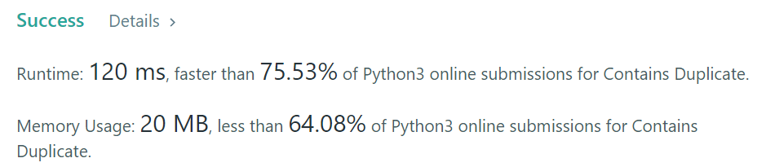

Others:

return len(nums) != len(set(nums))

